Advanced Composition/ Great World Authors
Grade: 11 Summer Reading Requirements
To the future Advanced Composition/ Great World Authors Students and Parents,
Welcome to an exciting summer!
Research shows that students who read continuously throughout the year improve their reading and writing skills altogether. What better way to prepare for the ACT? All students will be given reading assignments that will be due the second week of school (the date is tentative).
Below is a list of books for Summer Reading. There are 4 books, you are required to read 2. Please, do some research before making your final decision. These books can be ordered through amazon.com, or if you should find another online source, please use it. Purchasing your own books will allow you to annotate within the book as opposed to keeping a reading journal or using post-its for notes.

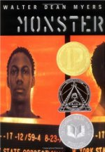 Monster by Walter Dean Myers 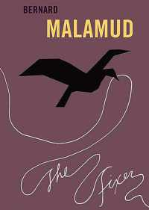 The Fixer by Bernard Malamud

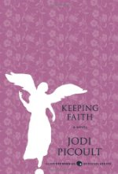 Keeping Faith by Jodi Piccoult 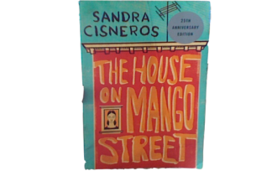The House on Mango Street by Sandra Cisneros

These books can be purchased (which I would prefer) but they can also be downloaded on a handy device (I would suggest e-books).
As your read, annotate each text.

Ideas for Annotating A Text

Underline, star, highlight, box, circle whatever words, phrases, or sentences that catch your attention.
Write brief comments in the margins
- observations about what is being said or done
- what you are reminded of (people, feelings, places, moods)
- questions you have
- ideas that occur to you
- things that you agree or disagree with
- any connections you are making
- summary comments
- identify themes being developed
- any literary devices being used
***Please Note: If you are unable to write in the books, create a min-reading journal or use sticky notes. Whatever you choose, be able to fully analyze each novel you read and be prepared to develop 2 Essays.

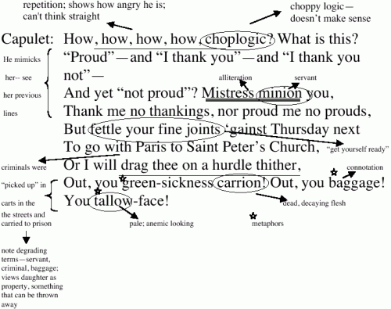
How do I annotate if the book has been downloaded on a device? Keep a notebook but be sure to follow similar rules and always explain/ point out what it is your notes are referring to.

The Assignment…
When we return from summer vacation, you should be prepared to discuss the two novels read during the summer. I will be looking at your annotations as well as assigning 2 different types of essays.
Essay 1: A Character Analysis
Essay 2: Compare/ Contrast Essay
I will give you a detailed description of each assignment when we return. I do not want you to “read” for anything in particular or distract yourself from the story, characters, etc. Your primary focus should not be strictly on the finished product (your essays), but rather on several aspects of the book and your interpretation of it.

Warning: You cannot wait until last minute to read these novels. Choose a pace that is comfortable for you and make it a priority to read a little every day as to not overwhelm yourself. Make it a goal to complete a novel every month of the summer, or give yourself a due date for each one. Whatever you choose, do not wait until last minute to start reading!

Take care and Happy Reading!
Mrs. Evans
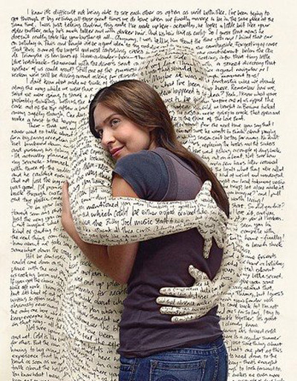 I LOVE READING!

Summer Reading Essay Assignment
This will be completed when we return from Summer Break! This is what to expect:
Both Essays should include an Introduction, Body, and Conclusion. This is to be written from 3rd person point of view and with formal vocabulary. Write to impress and explain how much you know about your reading.
Essay #1: Character Analysis
This essay should follow the format of essay writing and include ideas developed from the reader. Choose a character from one of your two novels and develop an analysis of the character.
Focus on the purpose of the chosen character in the novel or when and how a sudden change occurs (the turning point) and why the character responds.
Essay #2: Compare/ Contrast Essay
This essay should follow the format of essay writing and include ideas developed from the reader. Pick a specific element from each novel to focus on.
You can compare two protagonists, themes, motifs, characters, etc. Whatever you choose, be specific and use examples to support your ideas.

